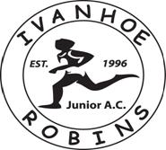
Club/Community Partnership award winners 2009
Junior Club of the year 2008
Club Chairman: Paul Cox. Newsletter: Tony Greenaway
June 2013

This Month’s Newsletter
- Satellite Club
- Winter Presentation
- Club QuadKids League – Saffron lane
- Leicestershire & Rutland County Championships – Saffron Lane
- Oxford – Sandra Luke Memorial meeting
- Robin’s out & About – Fun Runs
- Track & Fields events
- Doncaster spring Open
- Charnwood 1st Open Meeting
- Club records & Personal Bests
- Leicestershire Schools Orienteering
- NWL Schools sports
- Future Races and events

Satellite Club
Ivanhoe Robins have launched a Satellite Club; the chosen name is the Young Forest Runners.
There is a facebook group set up by Ellie Shaw, so please join.
The sessions are being held on Thursday evenings at Newbridge. The club has been set up to help reduce the amount of dropouts in sports & athletics and is for those aged 15 and over. Please support this club and invite friends & family to attend.

Winter Presentations
Congratulations to the four older Robins who were presented with this year’s cross country season awards. A special well done to Sam for his efforts in the Derby Runner League and to Hannah for Winning the Ivanhoe Challenge race for the 10th consecutive year.
Boys Cross Country
Sam Oakley
Girls Cross Country
Hannah Cox
Coaches Special Award
Ellie Armstrong
Graham Blythe Trophy
Daisy Tyers
Winter Grand Prix
Under 9 girls
1st Isobel Edwards
Under 11 girls
1st Jasmine Greenaway
2nd Olivia Godsell
3rd Lorna Brierly
Under 13 girls
1st Isobel Armstrong
under 15 girls
1st Hannah Cox
Jt 2nd Ellie Armstrong and Harriet Roberts
Under 9 boys
1st Luca Michalowski
2nd Zach Michalowski
Under 11 boys
1st Ethan Tebbutt
2nd Joseph Talbott
Under 15 boys (no under 13's completed the series)
1st Zach Meakin
2nd Euan Tebbutt
Under 17 boys
1st Sammy Oakley

Club QuadKids League – Saffron lane - May
The Quadkids series started in mid-May, with following events in June & July
May QuadKids
A good turnout of Robins saw several Club records broken, details can be found later on in the newsletter.
Some highlights were the excellent performances by Neve Evens in the year 3 & 4 girls 400m. Jasmine Greenaway, Ann Johnson & Max Potter to easily win their heat in the year 5 & 6 600m. A very happy Eve Halsey came first in her 75m sprint heat.
Tom Blewitt-Jenkins & Lorna Briely both ran strong races against very competitive opposition.
Joseph Talbott’s brilliant throwing put him in contention with a 30m howler throw
The younger year 3 athletes gained some great track & field experience, getting used to starting the race with the loud starter pistol was a challenge. They all put good times in & are sure to improve on them at the next event.
Well-done to all the year 3 & 4 competitors. Lucy, Neve, Isabel, Safiyah, Rebecca, Aaron, Alistair, Luca, Luke, Max & Zach. And to 5 & 6 athletes Sarah, Lorna, Jasmine, Rebecca, Megan, Eve, Ann, Tom B-J, Tom Potter, Joseph, Jack, James and Abdullah
And a big thanks to parents who helped on the night, Sharon for taking the role of team Manager and field judge. Also to Adam Smith for volunteering to be a race official. If any parents would like to help out next time, please let Sharon know
Neve Evans was 1st overall in the Girl’s year 3 & 4. In the process Neve broke the 400m club record by 0.9 seconds
Jasmine Greenaway & Lorna Briely took second and third place respectively in the girl’s year 5 & 6.
Jasmine broke her own 75m sprint club record by .17seconds,
Tom Blewitt-Jenkins broke two club records, his own 75m time by 1.05 seconds, and the 600m by 0.7 seconds.
Results of these events will be on the website & www.quadkids.org when available.
June Quadkids
A larger turn out of Robins saw some great performances and team scores. Full details can be found on the website
Neve Evans once again came 1st overall, after scoring errors in the howler throw are corrected. Lucy Morrison was next for Robins with Alicia placed a great 26th
Max Potter with 214 points came second overall in the year 3 – 4 competition. Alistair Clarke was 5th with 205 points
Lorna Brierly came second overall in the year 5/6 girls with a score of 204 points, Jasmine close behind in third with 201 points
Top 5/6 boy was Tom Blewitt-Jenkins who came 9th overall with 192 points, next was James Schaefer (10th) with 191 points
Well done to all Robins who took part; Neve, Lucy, Alicia, Alistair, Aaron, Luca, Luke, Max, Zach, Liam, Sarah, Eve, Jasmine, Lorna, Megan, Olivia, Rebecca, Sophie, Hannah, Ann, Maisie, Tom, Tom Potter, Jack, James, Joseph, Kyle & Charlie. 28 Robins in total took part, an excellent turn out. Team results, 1st place for year 3-4 Boys and year 5-6 girls, second place for year 5-6 boys.
Leicestershire & Rutland County Championships – Saffron Lane
The County Championships were held over the weekend 25th & 26th May.
In the QuadKids event, James Schaefer took Silver & Jasmine Greenaway took gold.
Also competing in the Leicestershire competition were Megan, Luca & Neve.
Several Robins took part, either representing the club or their 1st claim clubs
Well done to Harriet Roberts, Harris Reeves, Adam Smith, Harriet Mckenzie, Nathan Lewis, Daisy Tyers, Millie Shaw, Leah Smith, Amy Shaw, Lucy Roberts for all reaching the finals
Full Results can be found on the Power of 10 website. www.thepowerof10.info and Isportreg website
Oxford Sandra Luke Memorial
A reduced turn out of Robins took part in the event, mainly due to a YDL event being held on the same weekend. The Robins still managed to bring back a Silver (Millie Shaw) & Bronze (Jasmine Greenaway) in the 5 step competition.
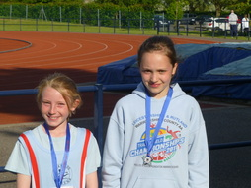
The full list of Robins who took part & their achievements are:

5 star

Well done to Millie (Silver Medal) & Jasmine (Bronze Medal), both achieving a 5 star
5 star awards for Amy Shaw (4th overall)
4 star award for Harriet McKenzie & Joseph Talbott
2 star for Hannah Edwards & Rebecca Talbott

10 Step

Well done to Lucy Morrison, achieving a 8 step certificate & coming 4th overall. Isobel Edwards for achieving a 6 step award & Noah Bishop for achieving a 4 step certificate
Track and Field events
With the track & field season in full flow, Open events are being held at athletics tracks all over the Midlands and further afield.
The Charnwood AC 1st Open meeting in June saw another great turnout of Robins, with several young athletes attending an Open meeting for the first time. The Robin’s had 7 representatives,
Also doing well were Older Robins representing their first claim clubs (Burton & Charnwood). Many achieved personal best times & distances. Full details can be found on the Power of 10 website
Well done to Lorna, George, Tom, Neve, Henry, Luca and Jasmine for posting some great times & distances
The next meeting will be held on Wednesday 7th August, from 6.30pm. Entries can be found on the Charnwood AC website. www.charnwoodac.co.uk
Doncaster Open Meeting
Jasmine Greenaway took two Bronze medals in the 80m & 150m sprints when up against some strong opposition from the Northern running clubs.
Club Records and Personal bests
Several of our athletes representing Ivanhoe Robins have either set or broken the Club records.
With the local Open meetings and Oxford trip giving opportunities to both young and old to try and better the records. The list is being changed weekly so look out for news on the website.
Full Club Record details can be found on the website, so if you believe you have broken or set a club record whist representing the Ivanhoe Robins or school, (not other clubs), please let me know and I will add your name & record details to the list as long as they qualify as per club rules.
Personal bests by the older Robins are being achieved on a weekly basis, too many to list so a big well done to all.
Don’t forget to register on Power of 10, this will publish all your events that you took part in. If you would like your page on the website, please let me know & I will add it to the Robins Power of 10 page.

Leicestershire Schools Orienteering
Following the very successful orienteering training event at Snibston, several Robins took part at the event held at Bradgate Park .
Below are a few photos from the event. Full results can be found on the Leicestershire Orienteering Club website Special congratulations to Vincent Stiles, Sammy Oakley, Joseph talbott, Ethan Tebbutt, Hannah Cox, Eve Halsey and Rebecca Talbott who all won there respective age groups.
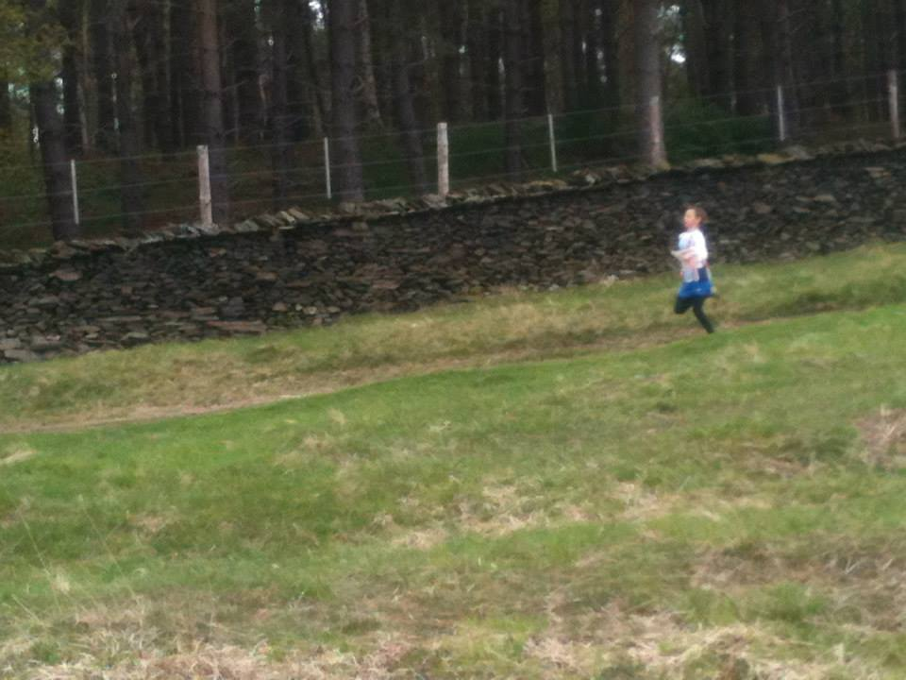
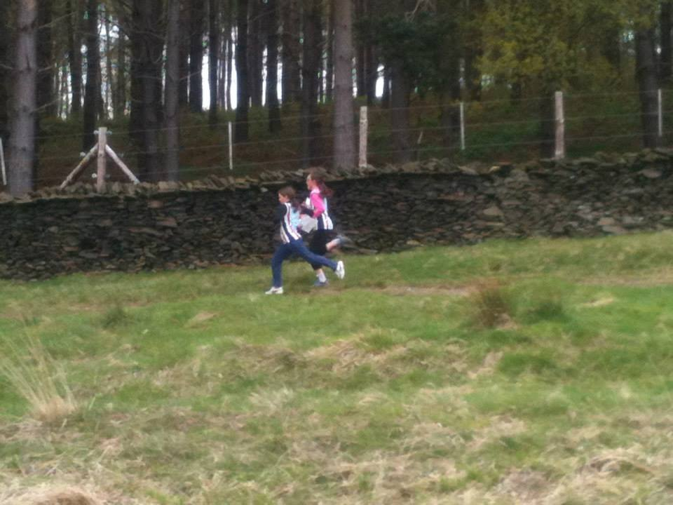

Leicestershire Secondary School’s Athletics Championships
Saturday 8th June saw a number of Robins who had reached the secondary school finals competing at Saffron Lane. Amy Shaw won the junior girls javelin, Daniel Edgecombe won the junior boys high jump and Hannah Cox won the Inter girls 3000m. As the results have not been published apologies to anyone missed off, but well done also to Harriet Roberts, Daisy Tyers, Bella Kemp, Nathan Lewis, Jake Shaw, Harriet McKenzie and any other Robins who were at the finals
Congratulations to Hannah Cox who qualified to represent Leicestershire at the English Schools athletics Championships for 3000m and commiserations to Amy Shaw who was only just short of the qualifying distance at Javelin. This is a huge achievement as English Schools is the highest competition in which a junior athlete can compete.

NWL Schools – Saffron Lane
The North West Leicestershire schools athletics day took part at a packed Saffron Lane on the afternoon of Wednesday 19th June. With dozens of Ivanhoe Robins athletes representing their primary schools, many medals were claimed in most events such as the spints, relays, 800meters, throws & long jump. A noisy crowd cheered them on with some excellent performance. These children made the Robins proud with their track side behaviour, support of fellow club members & their professionalism.

Robin’s out & about – Fun Runs.
The Hinckley 5k and fun run took place on 19th June, no younger robins turned up for the fun run (but it was the same day as the primary school athletics) but 5 of our older Robins (and a coach!) ran in the 5k.
There were 190 runners in the race and our results were as follows:
20th Zach Meakin 18.33 (second junior male)
24th Hannah Cox 19.25 (first female)
54th Harriet Roberts 22.45
91st -93rd Ruth Shaw, Amy Shaw and Lucy Roberts 26.02
Full results can be found at. http://www.hinckleyrunningclub.com/

The Ivanhoe Runners Worthington 5 & 1.2mile fun run took part on the evening of the 25th June and as usual saw quite a good turnout of Robins
Results were as follows:
Shaw | Jake | Ivanhoe Robins | 153 | 1 | 07:26
Meakin | Zach | Ivanhoe Robins | 151 | 2 | 07:28
Lewis | Nathan | Ivanhoe Robins | 159 | 4 | 07:44
Armstrong | Isobel | Ivanhoe Robins | 143 | 5 | 08:25
Meakin | Jordan | Ivanhoe Robins | 152 | 10 | 08:36
Jackson | George | Ivanhoe Robins | 154 | 11 | 08:37
Roberts | Harriet | Ivanhoe Robins | 149 | 15 | 08:56
Talbott | Joseph | Ivanhoe Robins | 165 | 17 | 09:01
Shaw | Ellie | Ivanhoe Robins | 155 | 20 | 09:30
Greenaway | Jasmine | Ivanhoe Robins | 137 | 21 | 09:31
Shaw | Millie | Ivanhoe Robins | 157 | 22 | 09:42
Godsell | Olivia | Ivanhoe Robins | 171 | 23 | 09:53
Shaw | Amy | Ivanhoe Robins | 158 | 24 | 09:57
Bennion | Sophie | Ivanhoe Robins | 177 | 26 | 10:04
Roberts | Lucy | Ivanhoe Robins | 148 | 27 | 10:12
Allery | Thomas | Ivanhoe Robins | 175 | 28 | 10:17
Rawlings | Mia | Ivanhoe Robins | 170 | 31 | 10:33
Halsey | Eve | Ivanhoe Robins | 160 | 35 | 11:26
Armstrong | Libby | Ivanhoe Robins | 145 | 36 | 11:27
Talbott | Rebecca | Ivanhoe Robins | 164 | 39 | 12:47
Thanks to Alan Edwards for the results
Please check out the Ivanhoe Robins Website on the link below for regular updates, full results & information
www.ivanhoerobins.weebly.com
To contact me regarding any newsletter or Website issue, please email me rumbug68@hotmail.com
Thanks, Tony Greenaway

